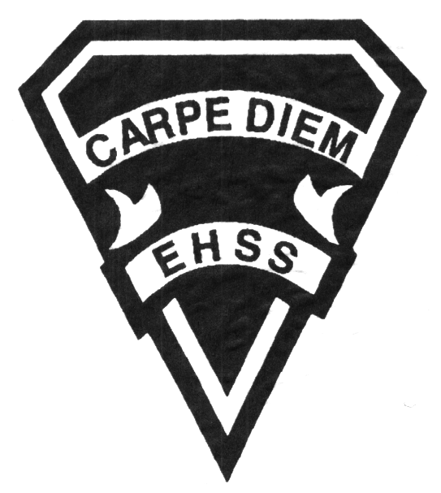

Course Description/Rationale/Overview: The Environment and Resource Management course investigates the complexity and fragility of ecosystems and the effects of human activities on them. Students will study the principles of sustainability and resource management and evaluate various approaches to achieving a more sustainable relationship between the environment, society, and the economy. We will investigate the complex ecosystem through Earth’s four spheres; Atmosphere, Hydrosphere, Lithosphere and Biosphere.

**2019/2020**

### The Environment and Resource Management

**Social Sciences Department**

## Earl Haig

SecondarySchool

# **CGR4M**

**Evaluation Profile & Outline**

**Class Requirements:** Students should have materials specified by the subject teacher at the beginning of the year.

The textbook for this course is Our Environment. Students will be issued this book at the beginning of the course. The replacement cost for this textbook $145.00.

**Assessment and Evaluation Strategies**

Students will also be expected to complete assessment activities of a formative nature in order to learn and to practice the specific expectations that will compose the summative evaluations. Examples of formative assessment may include homework checks, quizzes, peer assessment, presentations, reflection writing, role-play scenarios and observation.

Each unit or strand of the course will be evaluated using summative evaluations. Examples of summative evaluations are tests, case studies, interviews, reports, presentations, seminars, debates, research and other writing assignments.

**Late and/or Missed Evaluation**

##### Late Assignments*

For each assignment, the teacher will inform students of the due date. The teacher may decide to create an ultimate deadline. If an assignment is submitted after the deadline, the teacher may deduct marks up to and including the full value of the assignment.

**Missed Tests**

It is the student’s responsibility to make arrangements, ahead of time, for any tests/quizzes that are missed. If a student misses a test/quiz for an unforeseen reason such as illness, the student must bring a note signed by a parent or guardian**. Alternatively a medical certificate may be requested by the teacher.** The student must be prepared to write the test/quiz immediately upon return to school at a time determined by the teacher. Once the tests/quizzes have been evaluated and returned, students will not be able to make up a missed test - a mark of zero will be assigned.

**Subject-Specific/Department Information**

Teachers in the Social Sciences Department can be reached at (416) 395-3210, ext. 20075 or 20085. Parents wishing to meet with a teacher are requested to make an appointment with the teacher prior to coming to the school.

Office Hours: 8am to Start of School Day

Period 2 & 3

Email: [meraya.savicki@tdsb.on.ca](mailto:meraya.savicki@tdsb.on.ca)

Google Classroom Messaging

**Learning Skills**

**Responsibility** – meets deadlines; takes responsibility for own behaviour

**Organization** – establishes priorities and manages time; uses information, technology and resources top complete tasks time management

**Independent Work** – follows instruction with minimal supervision; uses class time appropriately to complete tasks

**Collaboration** – accepts an equitable share of work in a group; builds healthy peer relationships; works with others to achieve group goals

**Initiative** – looks for opportunities for learning; demonstrates curiosity; approaches new tasks with a positive attitude

**Self-regulation** – sets own goals and monitors own progress; seeks assistance with needed; makes an effort with responding to challenges

###### Final Mark

The final mark for this course will be determined based upon an accumulation of marks from unit summative activities and from a final summative evaluation

**Year’s Work 70%**

This is a culmination of evaluations that have been completed throughout the year. It may include tests, presentations, research, or topic specific assignments.

**Final Summative Evaluation 30%**

This will be completed during the final six weeks of the course and may include a variety of summative activities including an exam, project presentation, seminar or a writing assignment.

**Achievement Categories and Weighting**

* **Knowledge / Understanding – 25%**

Knowledge of facts and terms; understanding of concepts, principles, guidelines and strategies; understanding of relationships among concepts.

* **Application – 25%**

Synthesizing knowledge and understanding into new and familiar contexts as well as making connections between various contexts.

* **Thinking Inquiry – 25%**

Formulating questions; planning, selecting strategies and resources; analyzing and interpreting information, and forming conclusions.

* **Communication – 25%**

Communication of information and ideas, communication for different audiences, use of various forms of communication.



**2019/2020**

##### The Environment and Resource Management

**Social Sciences Department**

## Earl Haig

SecondarySchool

# **CGR4M**

**Evaluation Profile & Outline**

**Course Outline:**

Within each of the units 2 through 5, students will investigate the role of, spatial distribution and impact of human interactions on resources that are connected to the atmosphere, hydrosphere, lithosphere and biosphere. As well, students will determine the short-term and long-term consequences of promoting and maintaining sustainability within this sphere. Throughout this unit, students will identify and explore issues related to the management of the sphere’s resources and determine the effectiveness of government policies at the local, provincial and national and international levels. Students will complete the unit by interpolating what the future may hold for this sphere.

**Unit 1: Geographic Foundations and Environmental Systems**

This unit examines the relationships between the earth’s major components: the lithosphere, atmosphere, hydrosphere and biosphere. Students gain an understanding of energy flows, the structure of ecosystems and the processes that form them. Students will begin the process of creating an Environmental Database by researching information on different components and issues concerning the environment. Information is collected throughout the entire course and is evaluated at the end of the course.

**Unit 2: The Atmosphere: Human-Environment Interactions, Impact Assessment, Protection and Future**

**Unit 3: The Hydrosphere: Human-Environment Interactions, Impact Assessment, Protection and Future**

**Unit 4: The Lithosphere: Human-Environment Interactions, Impact Assessment, Protection and Future**

**Unit 5: The Biosphere: Human-Environment Interactions, Impact Assessment, Protection and Future**

**Unit 6: Planning for a Sustainable Future**

This unit begins with and examination of the rights and responsibilities of individuals to preserve the natural environment. Students investigate the contributions of various non-governmental organizations in identifying and solving environmental issues. In particular, the focus is on the impact these organizations have on planning at the local, regional, national and international levels. Students investigate and evaluate Canada’s roles and responsibilities in shaping a sustainable future. Students are asked to predict the impacts of resource management on environmental problems to be faced in this century.